Nature Scavenger Hunt

* This makes a great parent/child activity.*

Ages: Grades 1-4 Time: 30 minutes

No. of participants: 10-20 No. of additional adults: None necessary

Required supplies:
- laminated Nature Scavenger Hunt activity sheets (1 per person or pair)
- dry erase markers
- clipboards
- collection bags or containers

Objective: To get kids outside exploring nature. To force kids to slow down and look more closely at the beauty of nature all around them.

Lesson Plan Procedures
- Introduction:
  - Today you are going to go on a scavenger hunt. On this hunt you will find some beautiful treasures. The hunt will take place entirely outside and you’ll be looking for things found only naturally in the forest that we are in.
- Beginning Instructions:
  - Each of you needs to select a partner. (Optional, depending on age and group size)
  - Once you’ve chosen your partner come and get one of these sheets, a clipboard, a dry erase marker, and a bag or container.
- Main Lesson:
  - Choose one person to be the recorder and one to be the collector – although both of you will help with both tasks.
  - Your job is to go out into this area (predetermined and marked by the leader) and find as many of these things as possible in the next 20 minutes.
  - You can collect items that you find if they are lying on the ground, not attached to anything, and/or dead and put them in your bag or container.
  - When you hear this sound (your choice) please come back here right away. Stay with your partner at all times, stay in this area, no running and stay out of the creek!
  - This is NOT a competition or race! The goal is for you to find some really cool stuff that you’d probably miss otherwise and you will not find that stuff if you are rushing because a lot of it is sort of hidden. Have fun – Go!
- Conclusion:
  - After gathering the group and counting heads ask each group to share 1-2 of their favorite things they found or saw while they were on their hunt.

Nature Scavenger Hunt
We ask that you collect only things that are already dead, detached, and/or lying on the ground.
Otherwise, just enjoy looking so others may also have a chance.

A feather
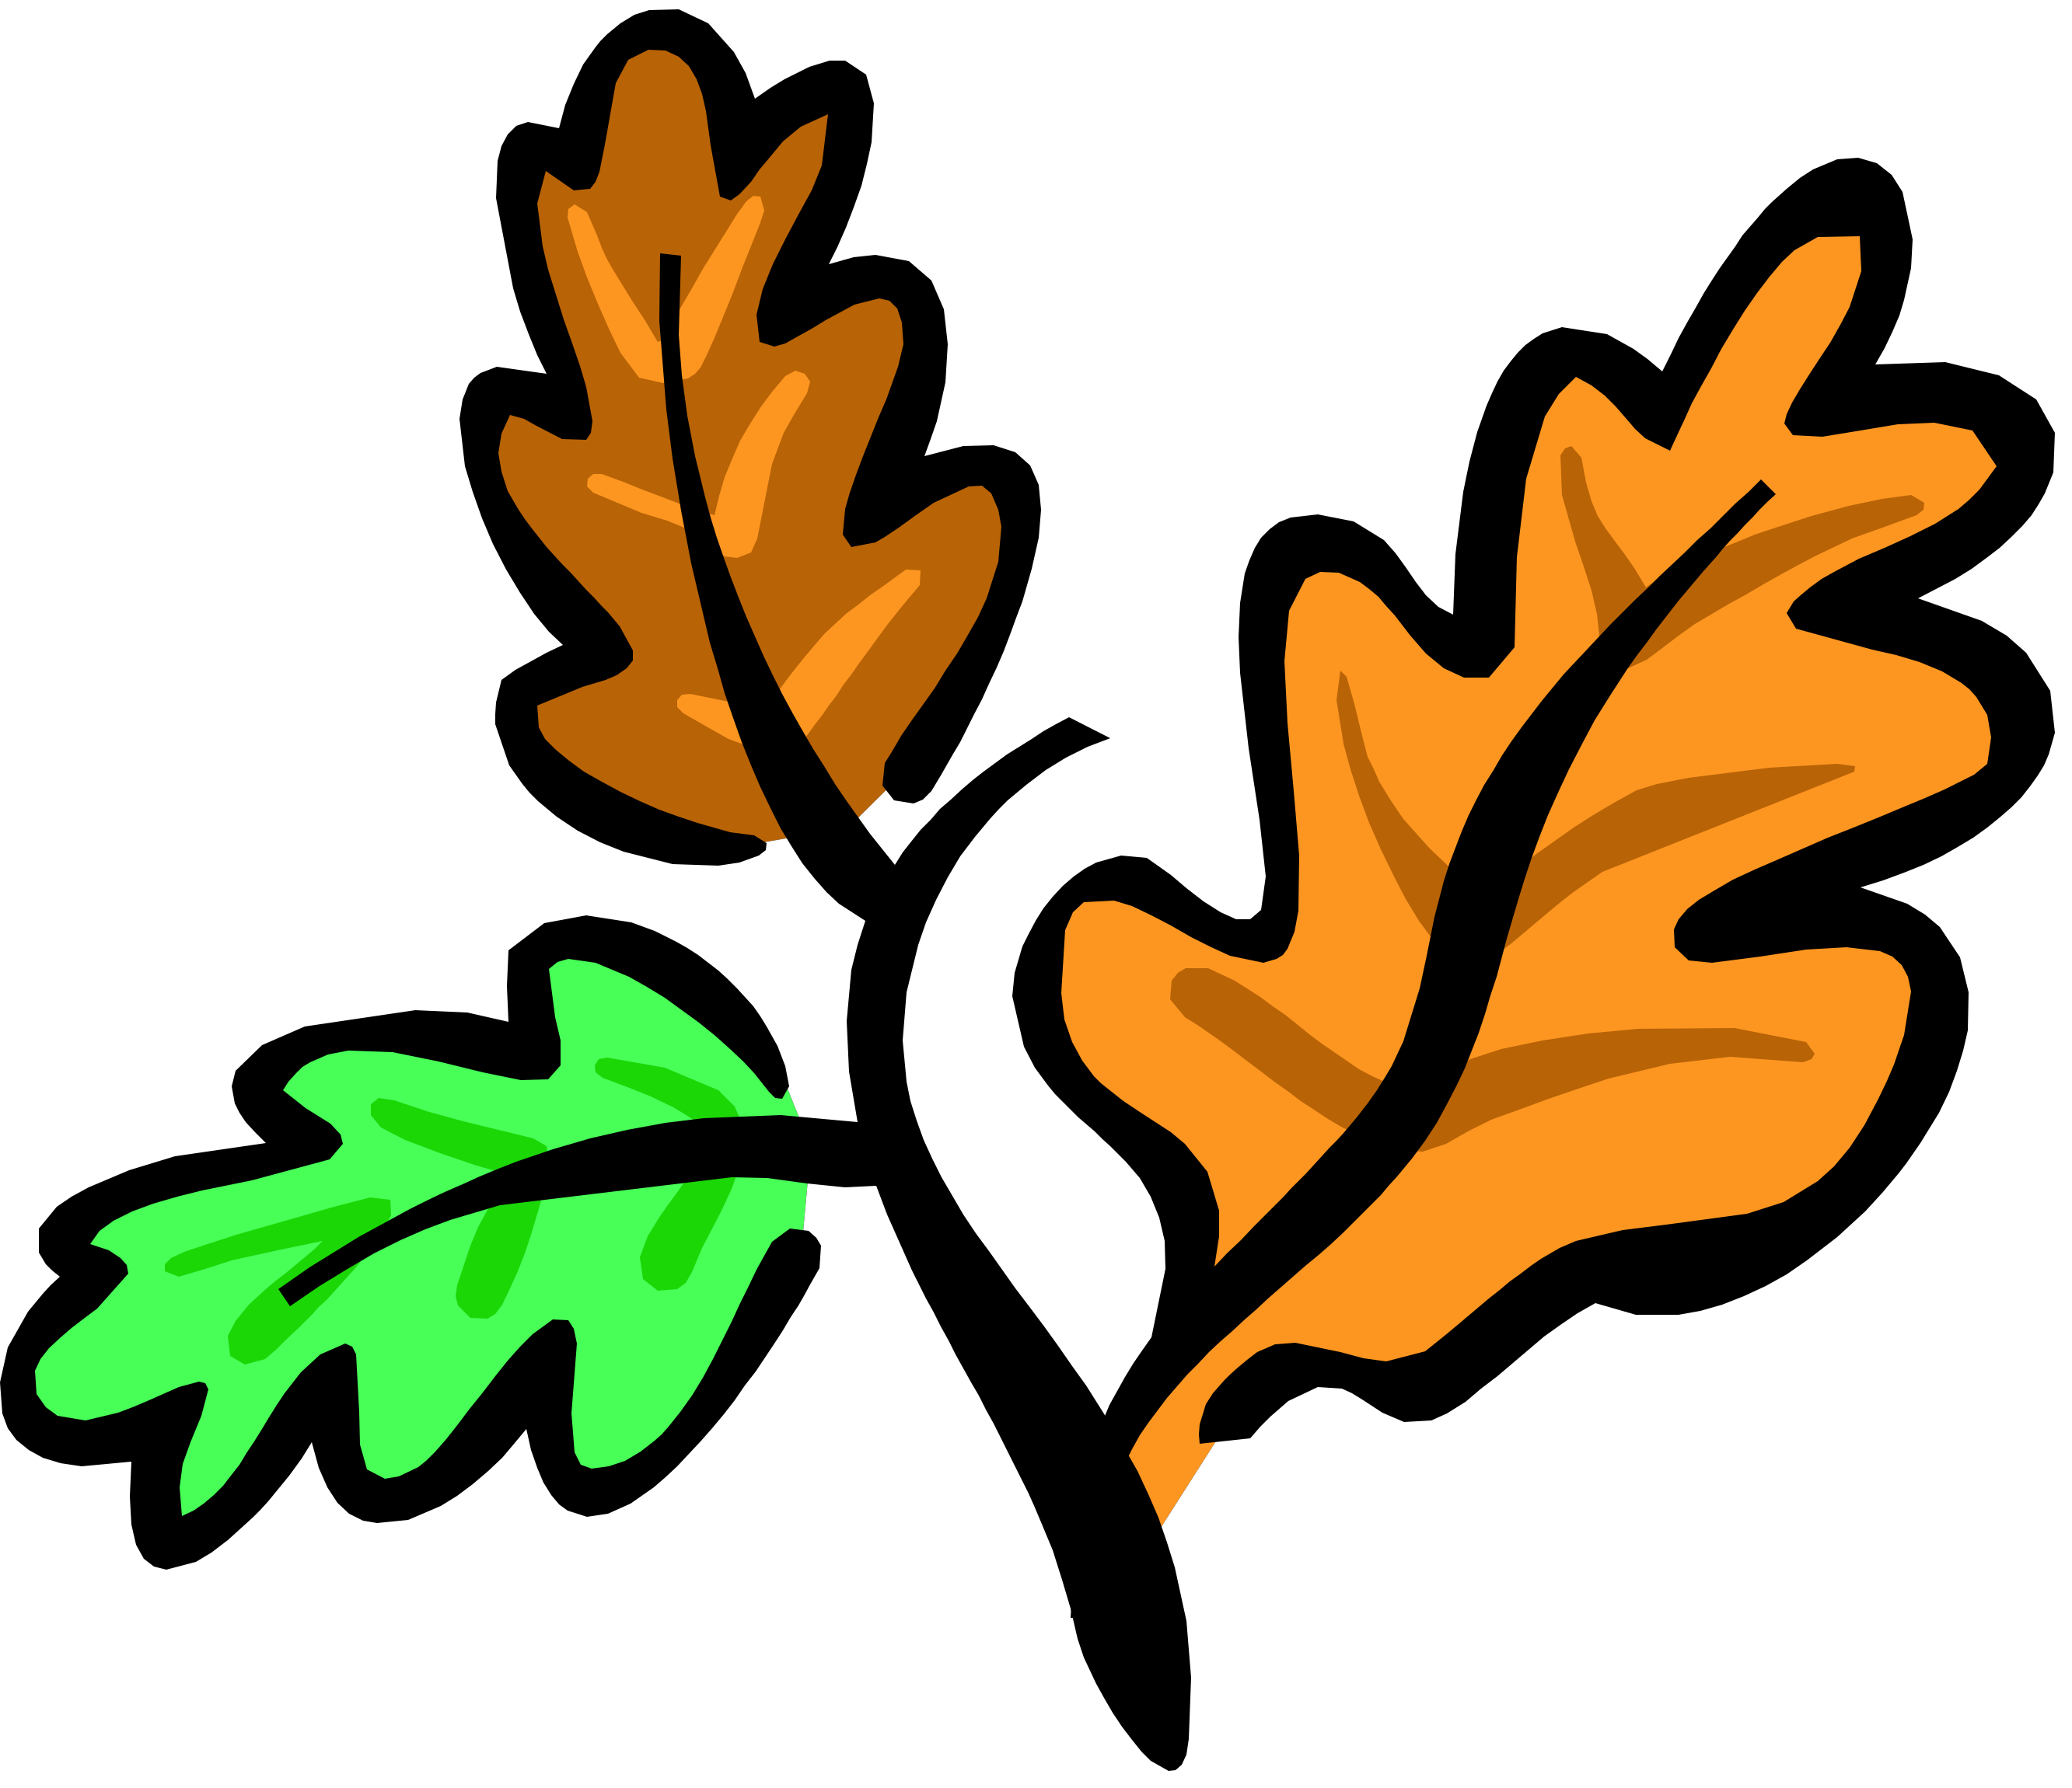
3 different types of seeds

Something with thorns

Something round

Something fuzzy

A multi-colored rock

A smooth, round stone

A leaf that’s been partially eaten by something – NOT you

Something sharp (different than the “something with thorns”)

A piece of bark that’s fallen off a tree

A mushroom – don’t touch!

An animal track

A stick shaped like a letter (other than I or l)

